Lakshmi Narain College of Technology & Science, Bhopal

Department of Electronics and Communication Engineering

Name: Madhuri Darkar Enrolment no.:0157EC181048 Class: EC V D

Date: 27/08/20 Page no.: 16

**PRACTICAL-6**

Aim: Perform basic mathematical operations on Scilab.

Software required: Scilab version 6.0.2

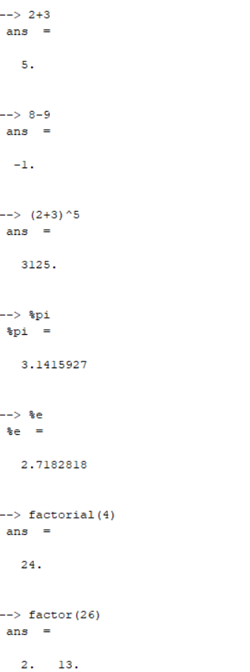

Lakshmi Narain College of Technology & Science, Bhopal

Department of Electronics and Communication Engineering

Name: Madhuri Darkar Enrolment no.:0157EC181048 Class: EC V D

Date: 27/08/20 Page no.: 17

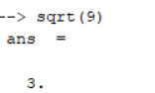

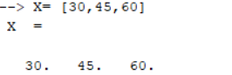

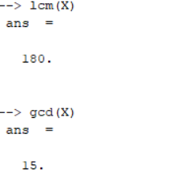

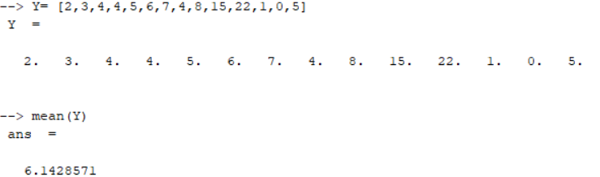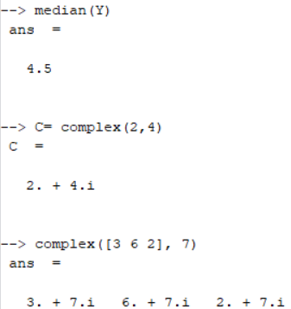 Teacher’s signature